**Introduction:** Developers at the Massachusetts Institute of Technology have constructed a program that introduces users of all ages to the world of digital animation. “*Scratch*” is a simple, user-friendly website that allows users to create and build animated clips, games, and many other innovative options. By building “blocks” consisting of pre-programmed actions and controls, learners at even the most basic level will acquire the fundamental programming skills and experience necessary to take on the ever-changing digital world. Users of all ages will benefit tremendously from this new fun and exciting animation tool!

**PART ONE: Welcome to *Scratch*!**

1. **Access *Scratch* homepage.** To begin, open your browser and type in the following URL: <https://scratch.mit.edu> . Welcome to the *Scratch* homepage! Let’s get started. 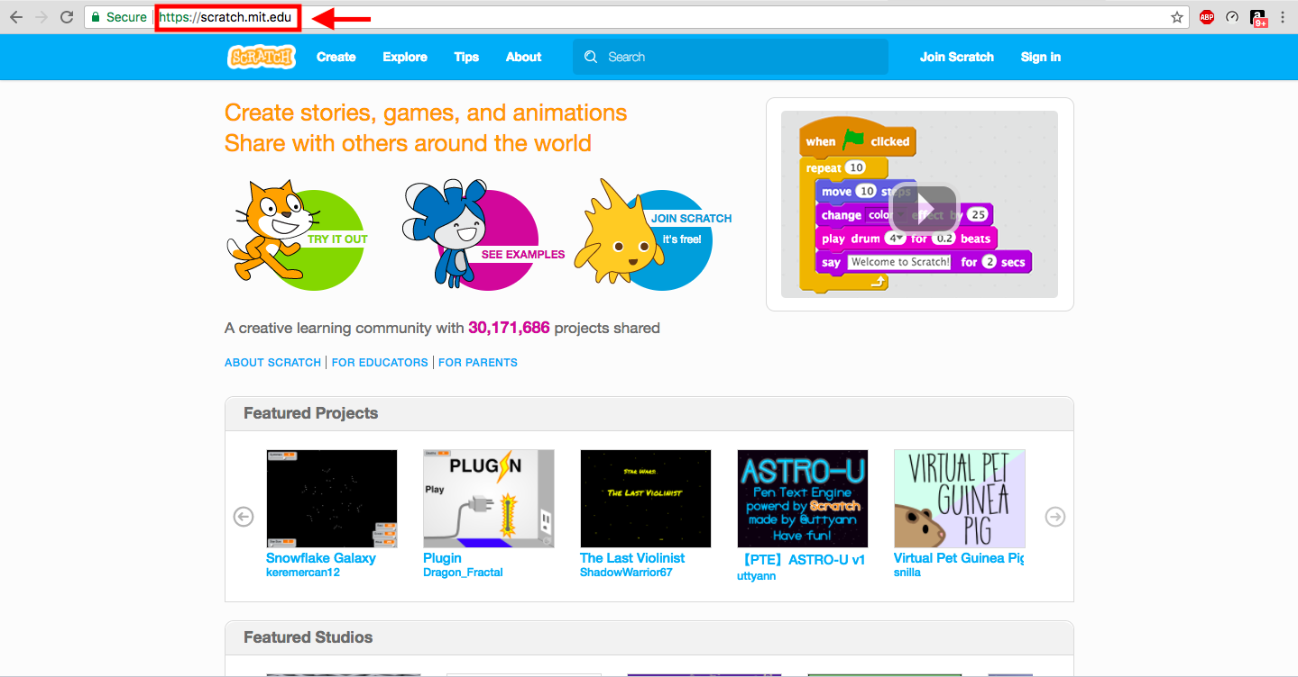

**Figure 1.1**

**2. Create/Log into your *Scratch* Account.** Once you have accessed the *Scratch* homepage (Figure 1.1), it is time to create your account. Click the button on the right side of the blue toolbar that says “Join Scratch” (Figure 1.2). Create your unique username and password, then fill out the following required prompts on the screen until you have finished making your account (Figure 1.3).

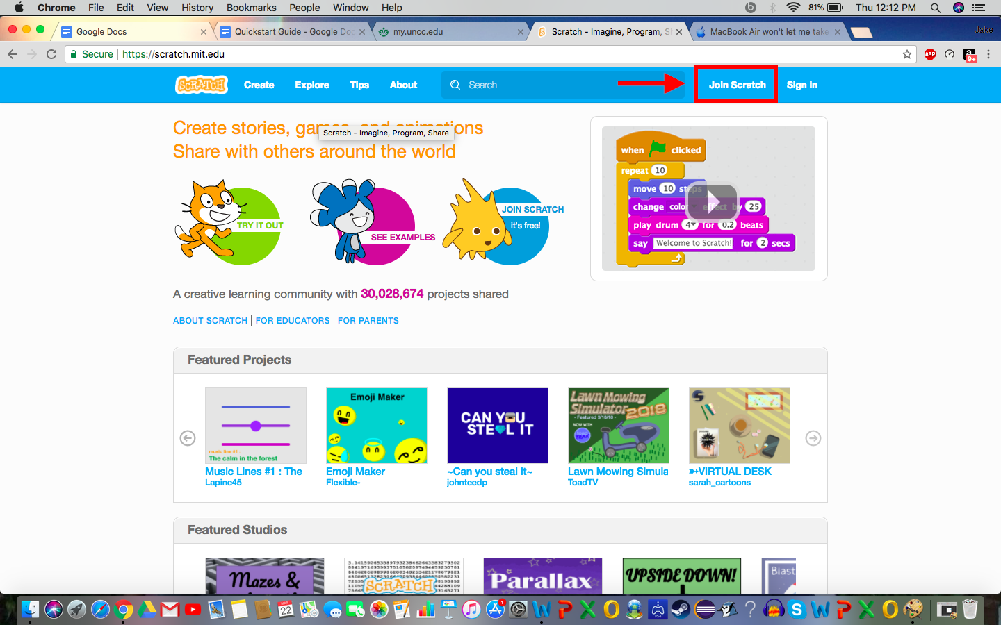 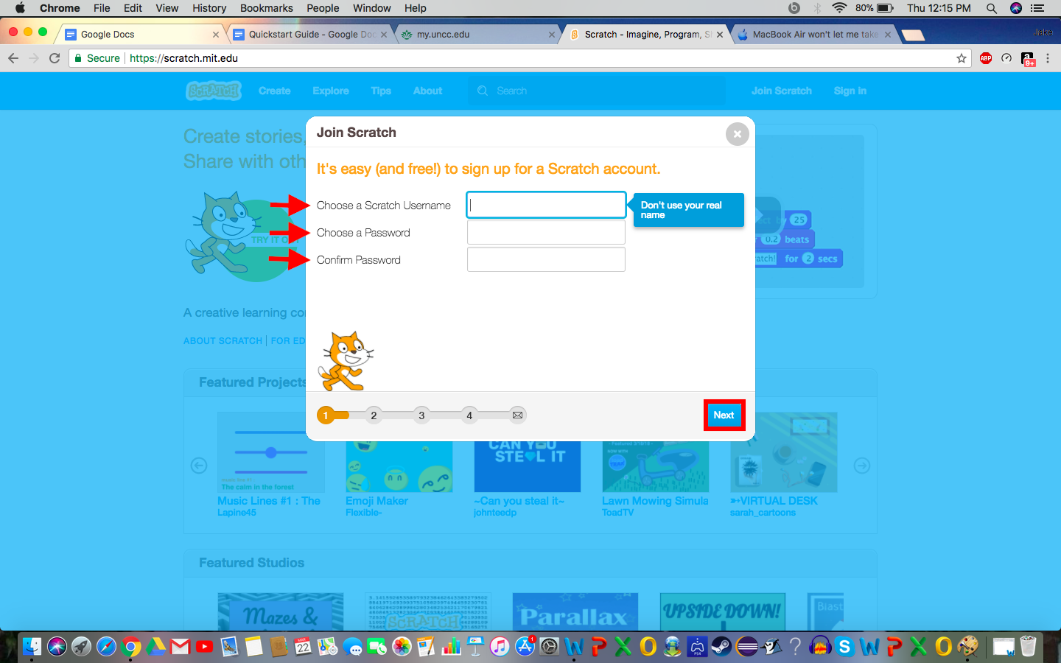

**Figure 1.2** **Figure 1.3**

**If you have already created an account, please click the “Sign In” tab on the far right side of your screen. Fill in your credentials and sign in.**

Now that you have logged into your new or existing account, you are ready to begin your first project. Start by clicking the “Create” button on the far left side of your blue toolbar. (Figure 1.4)

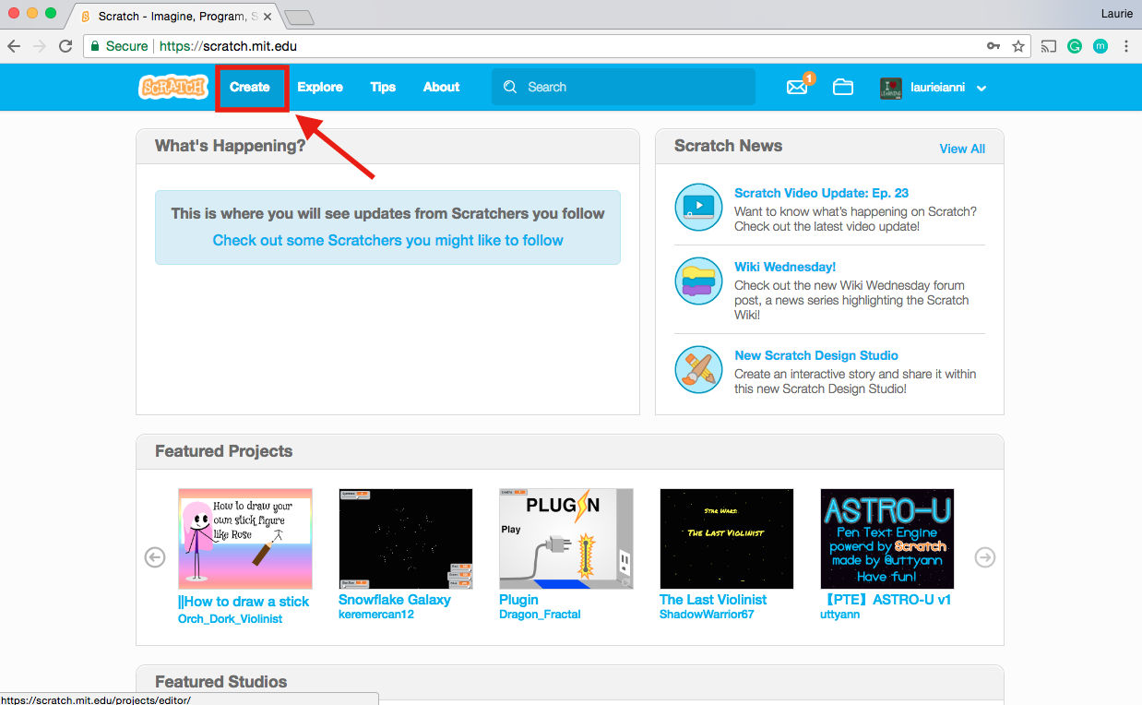

**Figure 1.4**

**Congratulations, you are now ready to begin using *Scratch!***

**PART TWO: Creating Your First Project.**

1. **Naming Your Project.** When you first open a new project, you will see a cartoon illustration, or “sprite,” of a cat on a black canvas or “stage”, three folders consisting of “Scripts,” “Costumes,” and “Sounds,” and a small textbox that says “Untitled.” To rename your project, select the text in the textbox and delete it. Type your new title in the now-empty space. (Figure 2.1)

1. **Delete the “Cat” Sprite.** If you wish to continue using the default “Cat” sprite, you may skip this step. If you’d like to use a different sprite, you can delete the Cat sprite by either right clicking on the sprite and selecting “delete” from the dropdown menu (Figure 2.1). 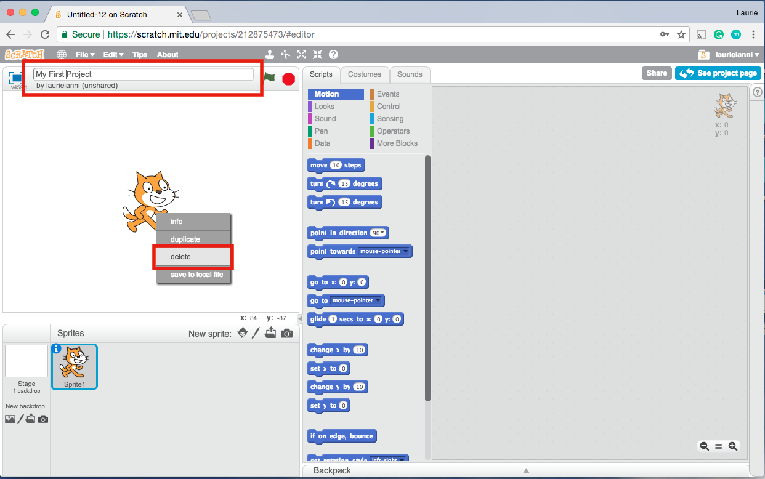

**Figure 2.1**

1. **Choosing a new sprite.** To choose a new sprite from *Scratch’*s built-in library, click the doll-like icon on the lower right side of your stage (Figure 2.2).

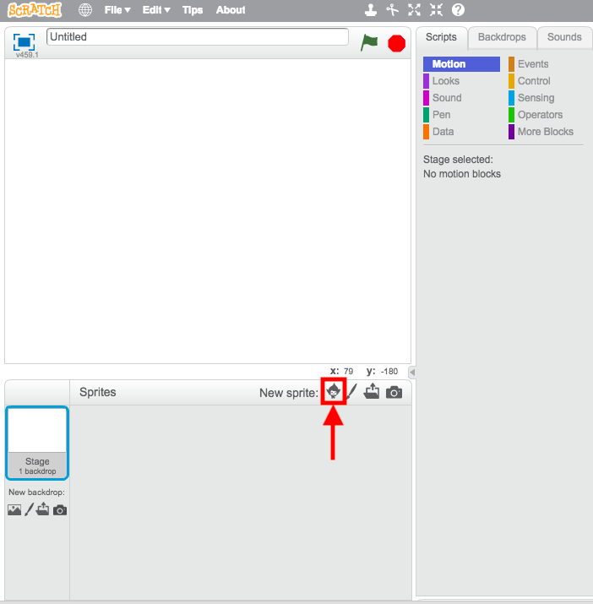

**Figure 2.2**

*\*More advanced users may want to draw and create their own sprites. This option can be accessed by clicking the paintbrush icon.*

Scroll through the alphabetized list of predesigned sprites and choose one you like. When you have found one, select the image and click “OK” at the bottom of the library screen. For this demonstration, we will be using the “Dinosaur 1” sprite (Figure 2.3).

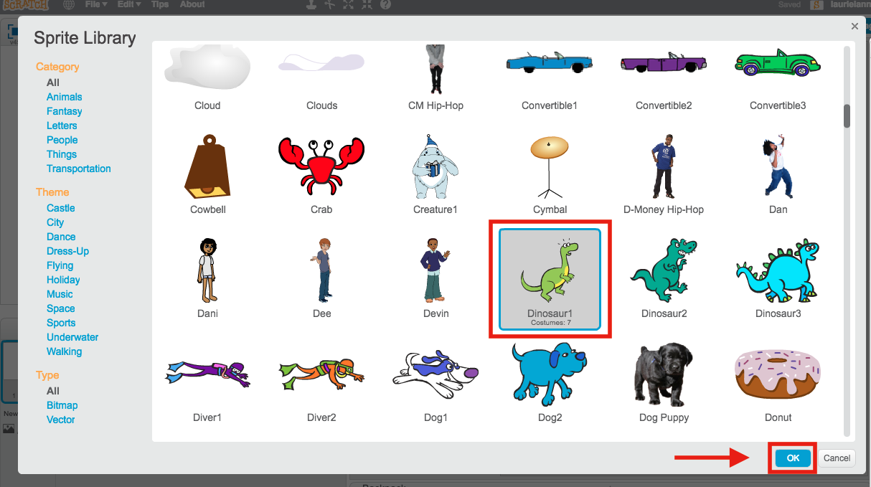

**Figure 2.3**

1. **Choosing a backdrop.** Now that you have chosen the perfect sprite for your project, it’s time to pick out its home! To choose a new backdrop, navigate to the bottom left side of your stage (Figure 2.4a). Scroll your mouse over the buttons underneath your “Stage” icon, clicking the one that says “Choose new backdrop from library” (Figure 2. 4b).

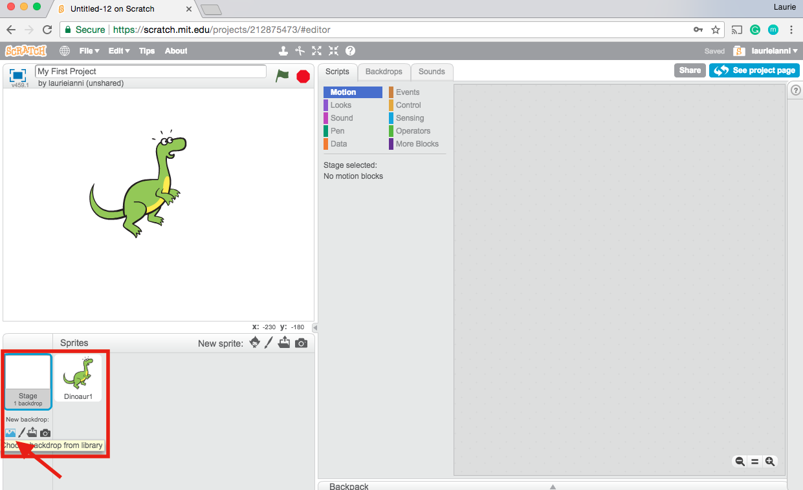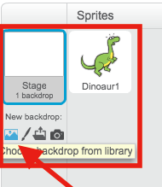

**Figure 2.4a Figure 2.4b**

Similar to when you chose your sprite from the *Scratch* library, an alphabetized list of different images will appear. Select the backdrop you prefer and press “OK” to set it as your stage. For this demonstration, we are using the “desert” backdrop (Figure 2.5).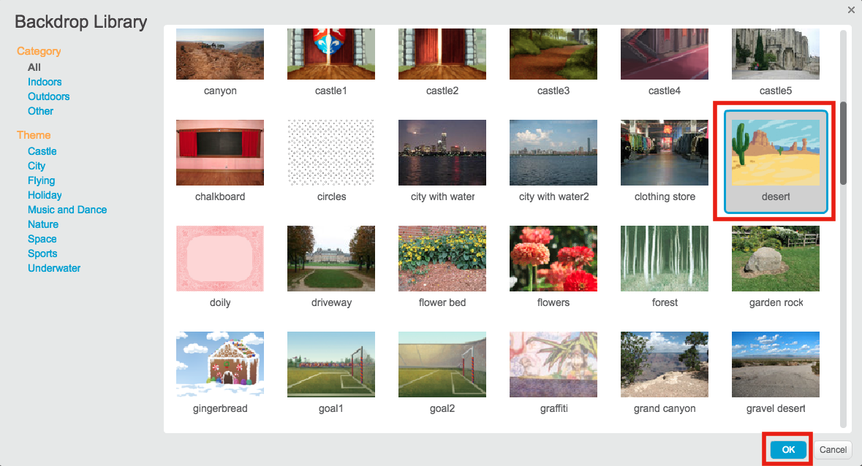

**Figure 2.5**

**Lookin’ Good! Let’s start animating!**

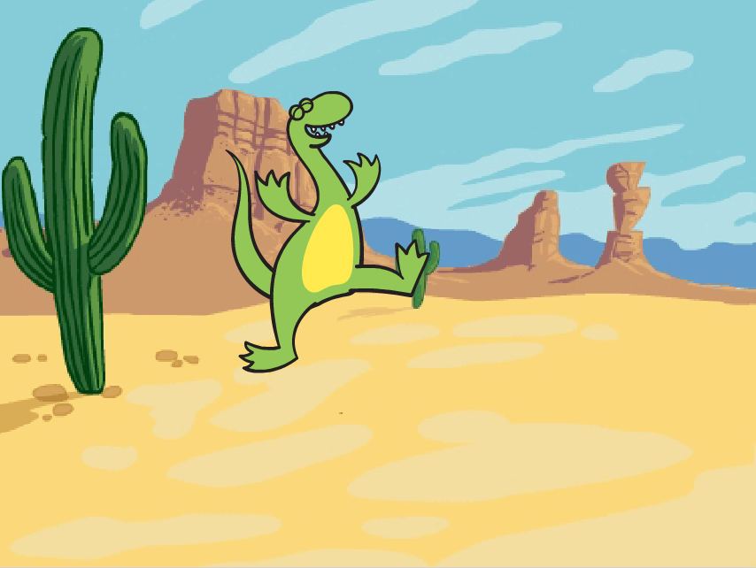

**STEP THREE: Scripts, Costumes, and Sounds.**

1. **Scripts: Motion.** The first script, or action, that we will be programming our sprite to perform is a motion. To do this, you will need to access the “Scripts” tab on your screen (Figure 3.1).
   1. There are 10 different categories of scripts that you can choose from; i.e., ‘Motion’, ‘Looks’, ‘Sounds’, ‘Pen’, etc. There are also corresponding blocks for each category. The blocks each have a specific code embed inside them, and when placed together correctly perform certain tasks or actions. For this demonstration, we will be starting in the “Events” category.
   2. “Event” blocks register user input, such as hitting the spacebar, and can be assigned secondary conditions or actions after a primary “Event,” has been selected.

*E.g., By dragging the “when space key pressed” and “move 10 steps” (located in the “Motion” category) blocks to the grey area to the right of your screen, you will notice that your sprite will move 10 “steps” across the stage. For help, see Figures 3.1, 3.2, and 3.3.*

**Figure 3.1.** Drag “when space key pressed” from the Events category to grey area.

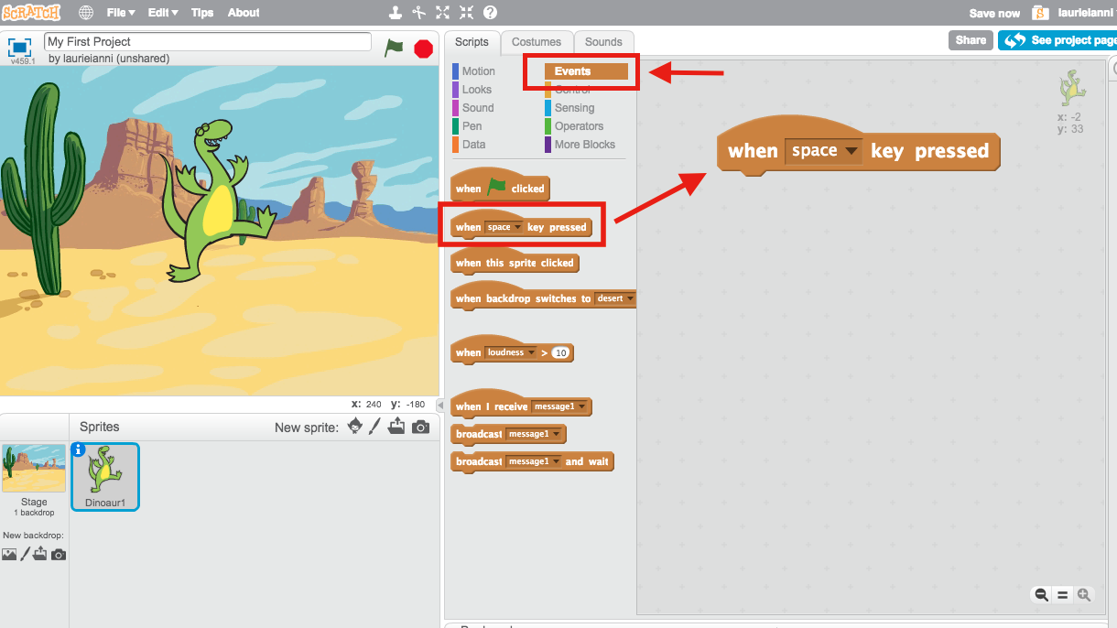

**Figure 3.2.** Drag “move 10 steps” block from the Motion category and connect it to your first block. The blocks will be connected when you see a white outline between the two blocks.

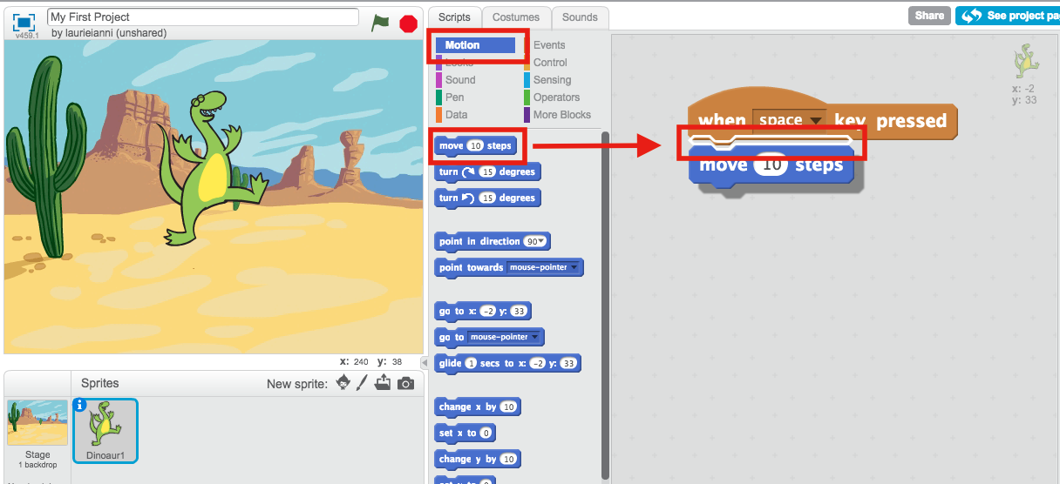

**Figure 3.3.** In order to display a more noticeable movement of the Dinosaur sprite across the stage, we have changed the amount of steps from 10 to 50. This can be done by clicking on the original number in the white circle on the Motion block and typing in a new number. Next, click the spacebar and watch your sprite move!

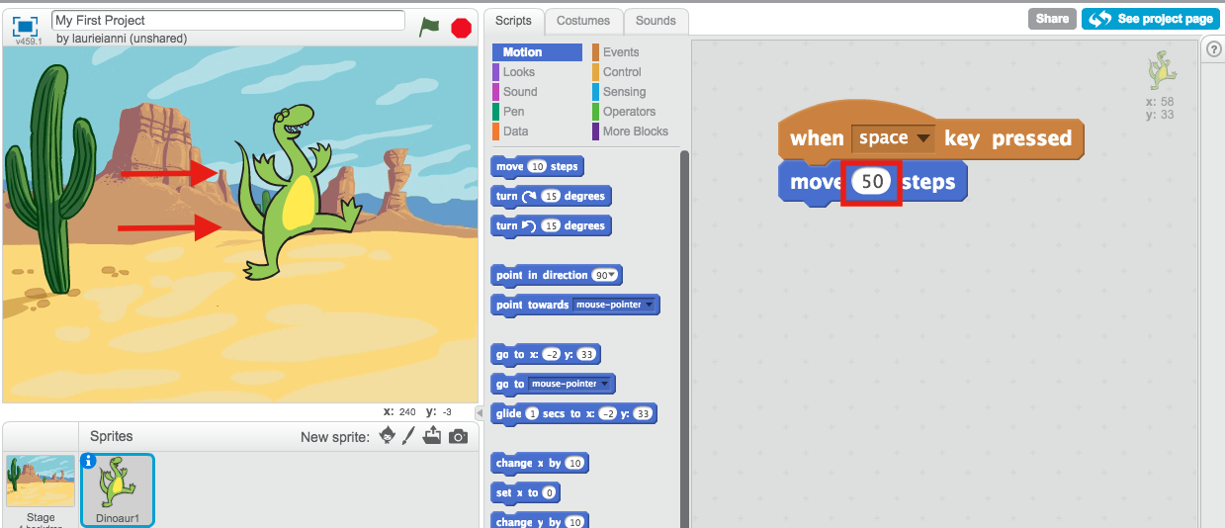

**2. Costumes: Looks.** Certain sprites on *Scratch* are included with several different “costumes” to choose from. The costumes can be accessed by clicking on the tab that says “Costumes.” The “Dinosaur1” sprite, which we have chosen for this demo, has seven costumes listed from “Dinosaur1a” to “Dinosaur1g” (Figure 3.4).

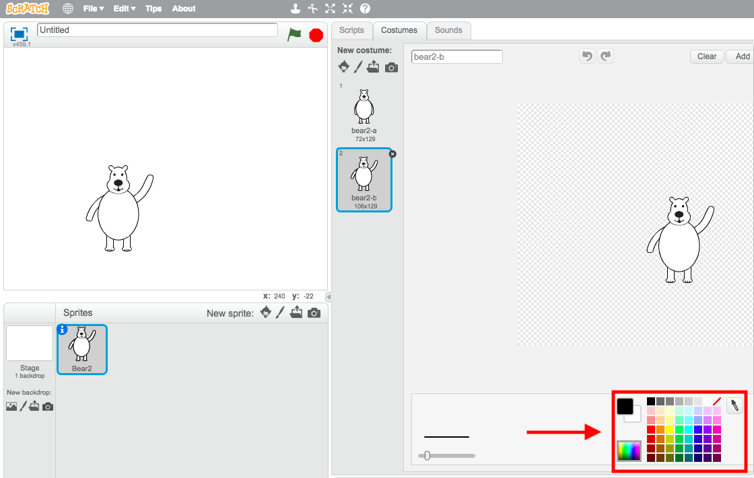

6. Choose animations for your sprite and click the green flag to test it out

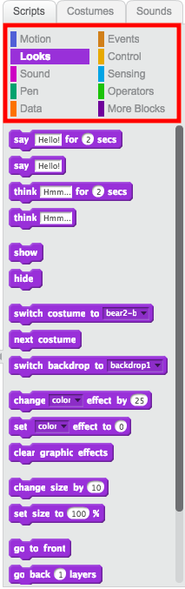

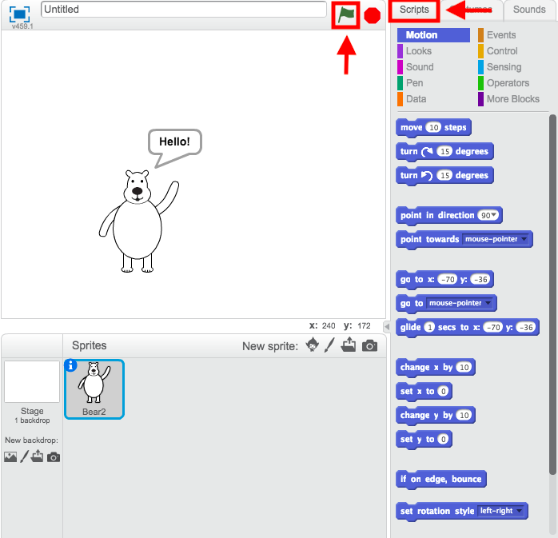

7. Add a sound to your animation

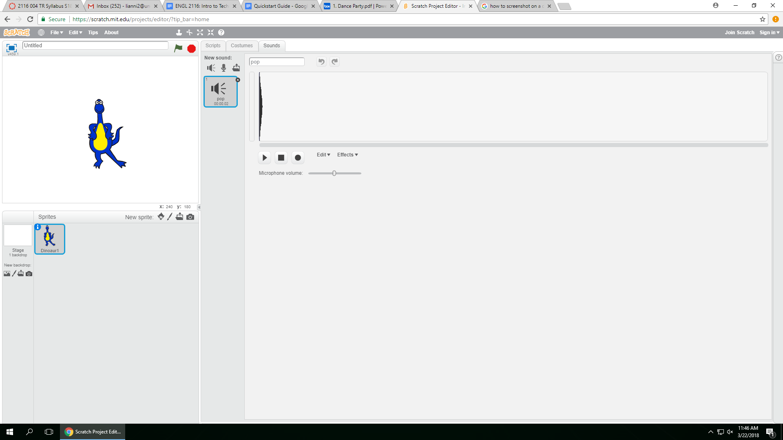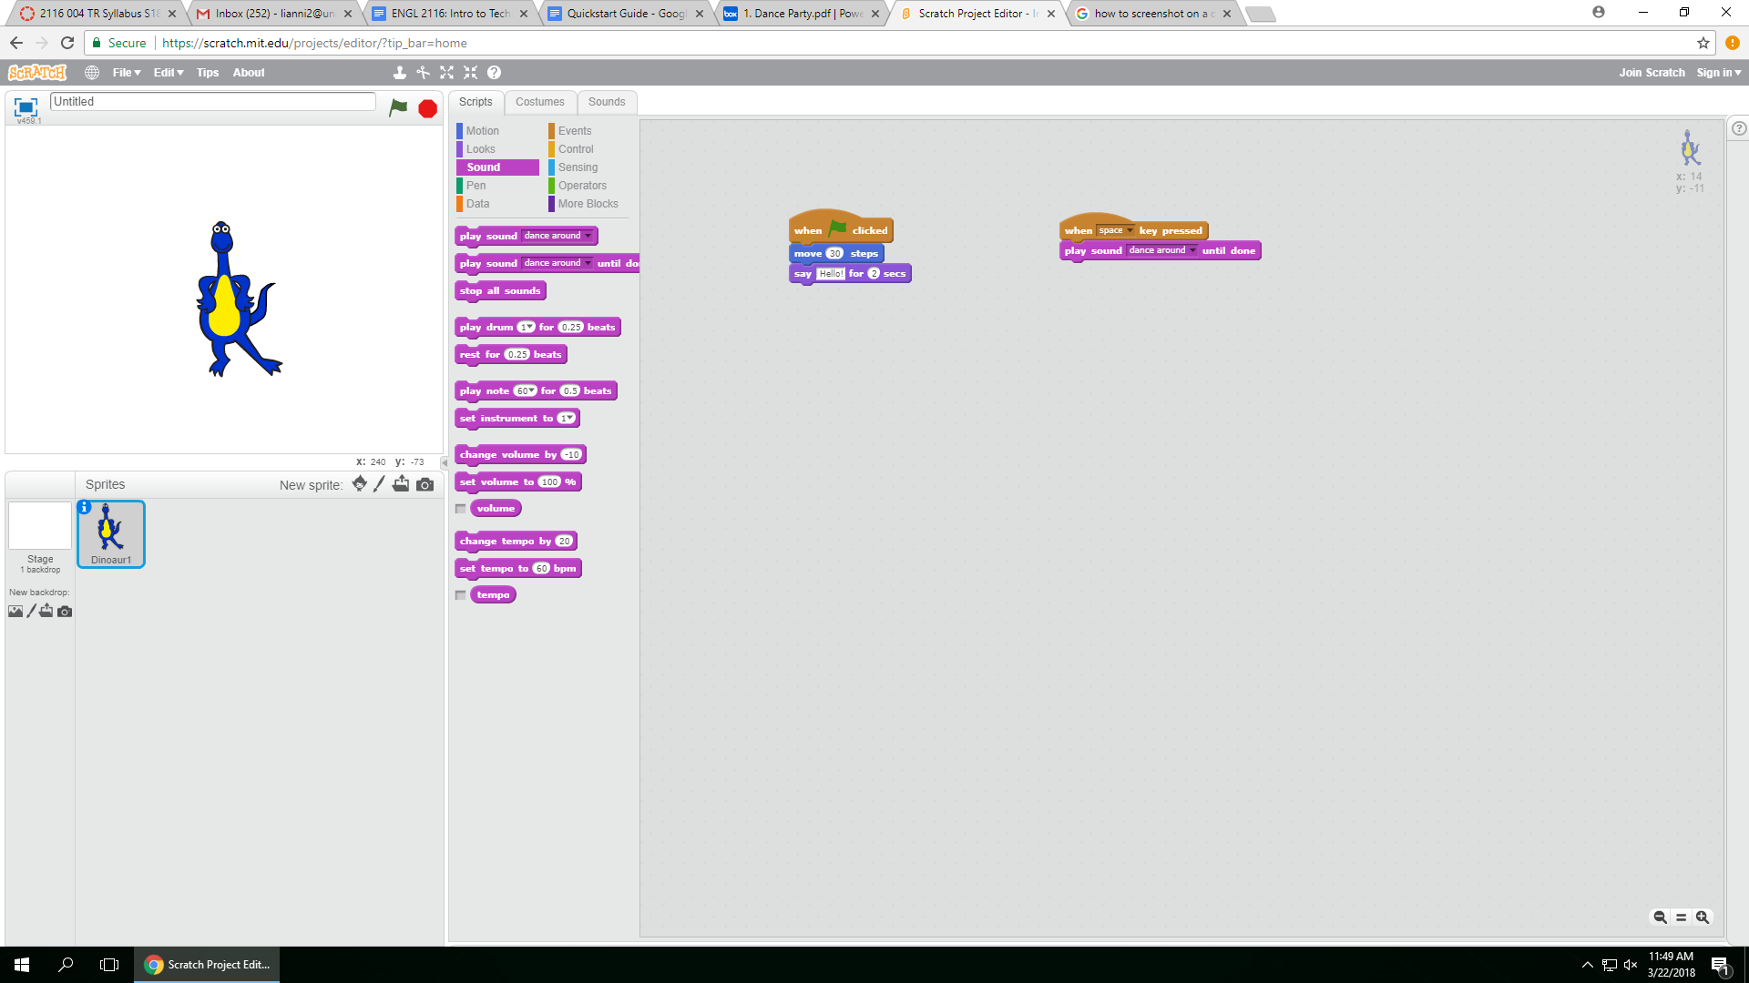

8. Add a background

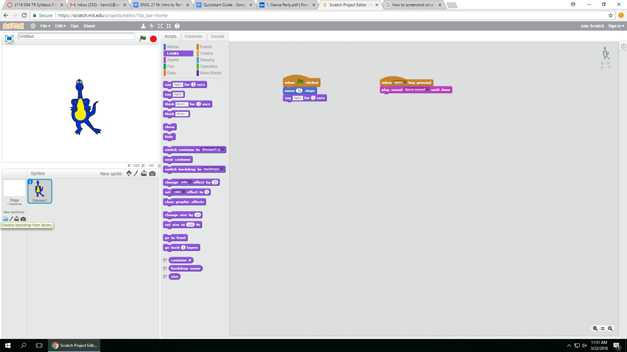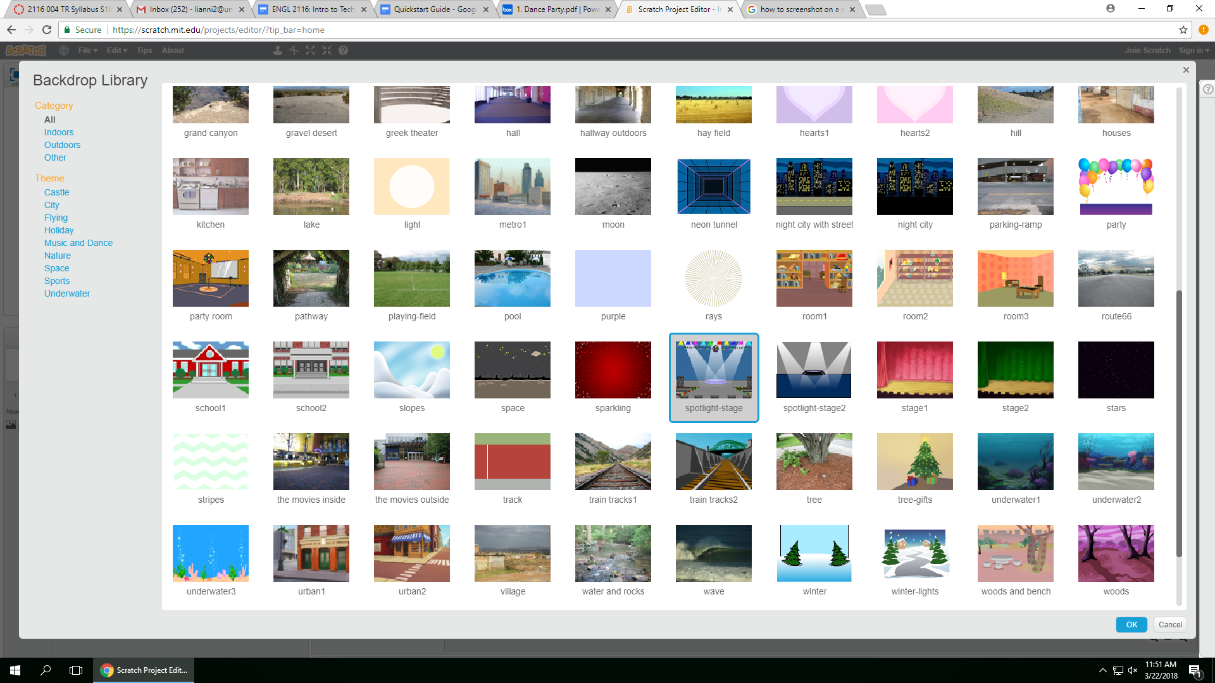

9. Changing the size of your sprite

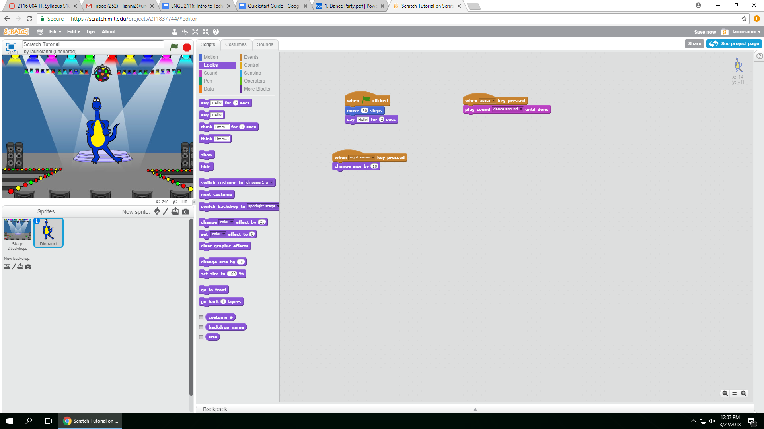

10. Add a title and save project

1. 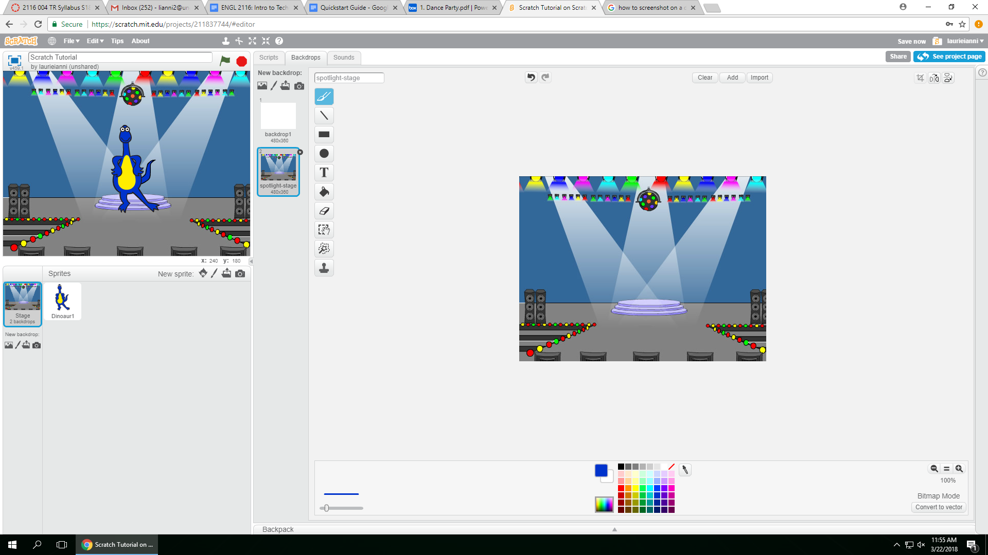

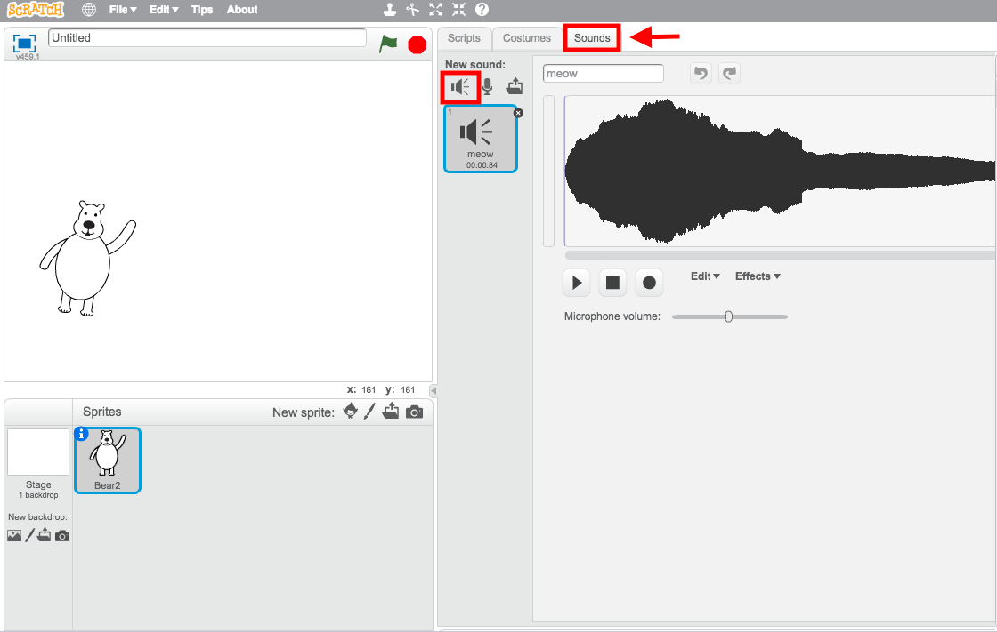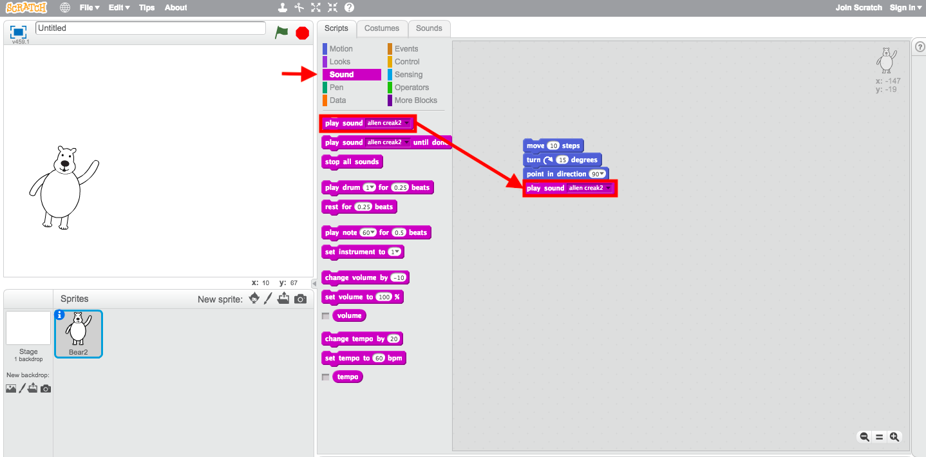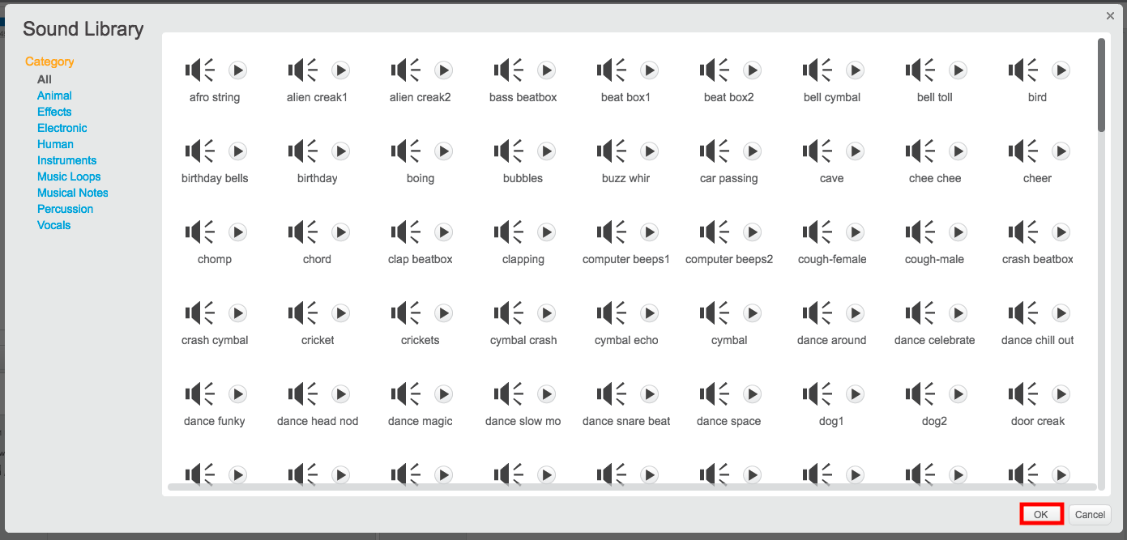

8. 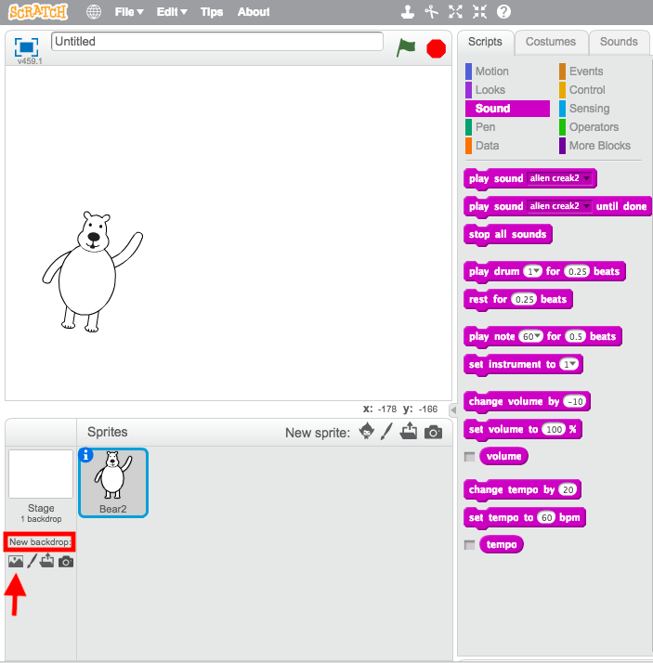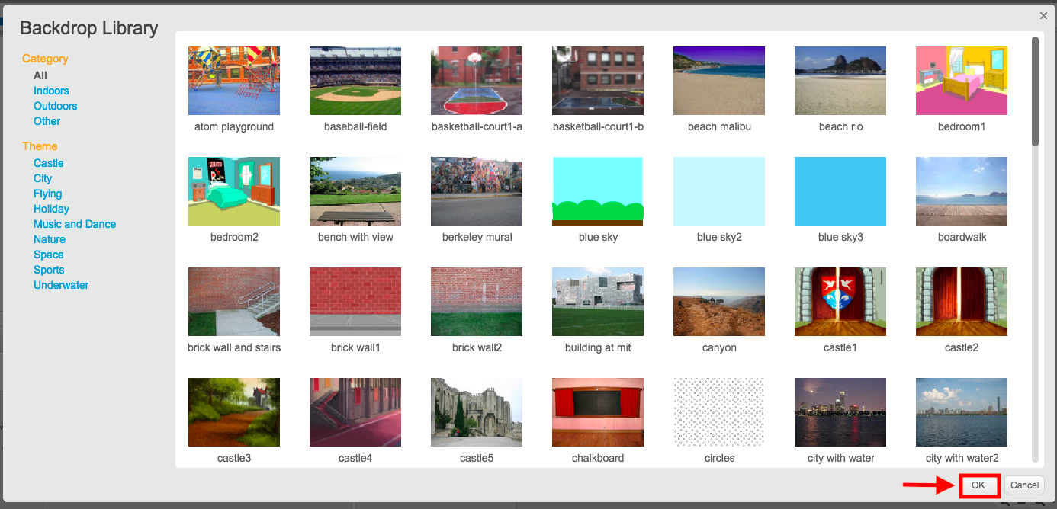

9.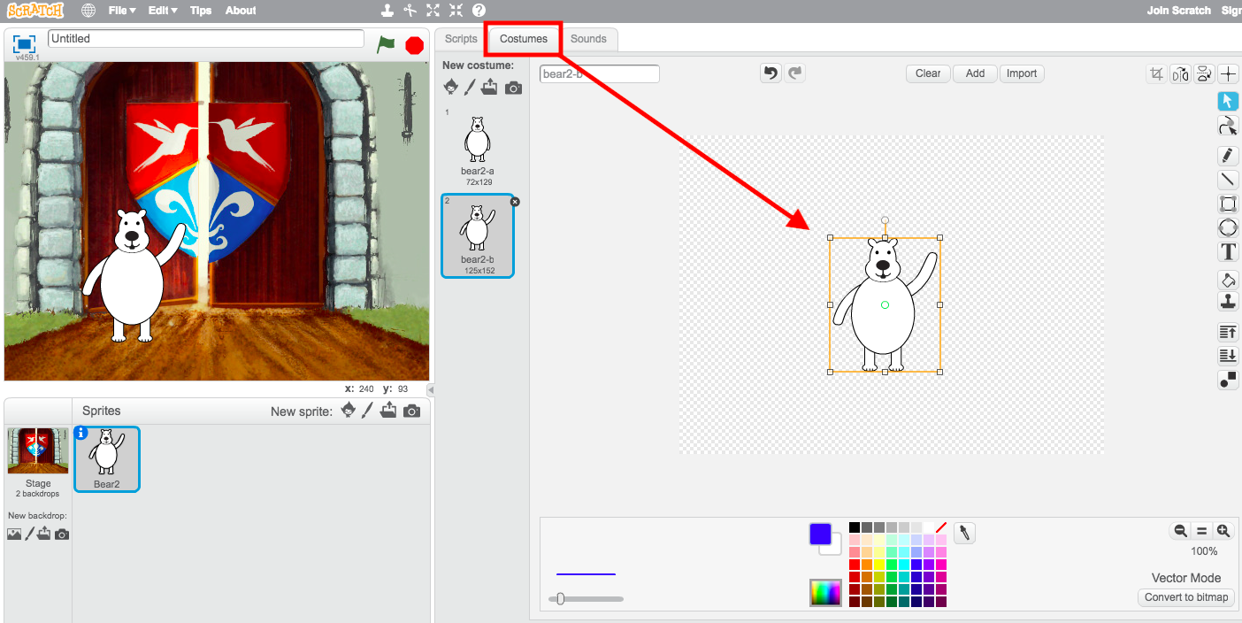

10. 